**EE2026 Assignment**

**Design outline**

The assigned task was to construct a 4-bit subtractor using 2s complement and a 4-bit adder. We know that using a 2s complement representation of the negative numbers, we can simply add the values together using a 4-bit adder to get the result. We also know that the result will be in its normal form if it is positive, and in its 2s complement form if it is negative. Whether the number is positive or negative is given by the MSB (Most Significant Bit) of the sum. Additionally, we know that the range of values that this subtractor can operate on **and output** is -7 to +7. Thus, we realize that with certain input combinations, it is possible to go above the output range of the subtractor. Therein arises the need for an overflow flag to indicate the validity of the output of the subtractor.

My implementation of the subtractor intends to make it simpler for the user to use by utilizing a **4-bit signed magnitude representation** of the input and output values. In addition to that, as mentioned in the above section, an overflow flag is implemented. As such, the input and output testing criteria are slightly different for my implementation as compared to those provided in the lab manual.

**Results of simulation˜j**

The inputs of the tests are modified from the provided values such that they are converted to the 4-bit signed magnitude representation which is consistent with my intended implementation. As such, the results are summarized below in the following table. I have also added 2 additional tests for the overflow flag.

|  |  |  |  |  |
| --- | --- | --- | --- | --- |
| A | B | S | overflow_flag | Time (ps) |
| 0101 (+5) | 0001 (+1) | 0100 (+4) | 0 | 0 - 100,000 |
| 0101 (+5) | 1001 (-1) | 0110 (+6) | 0 | 100,000 – 200,000 |
| 1101 (-5) | 0001 (+1) | 1110 (-6) | 0 | 200,000 – 300,000 |
| 1101 (-5) | 1001 (-1) | 1100 (-4) | 0 | 300,000 – 400,000 |
| 0111 (+7) | 1111 (-7) | 1010 (-2) | 1 | 400,000 – 500,000 |
| 1111 (-7) | 0111 (7) | 0010 (+2) | 1 | 500,000 – 600,000 |
| 0000 (+0) | 0000(+0) | 0000 (+0) | 0 | >600,000 |

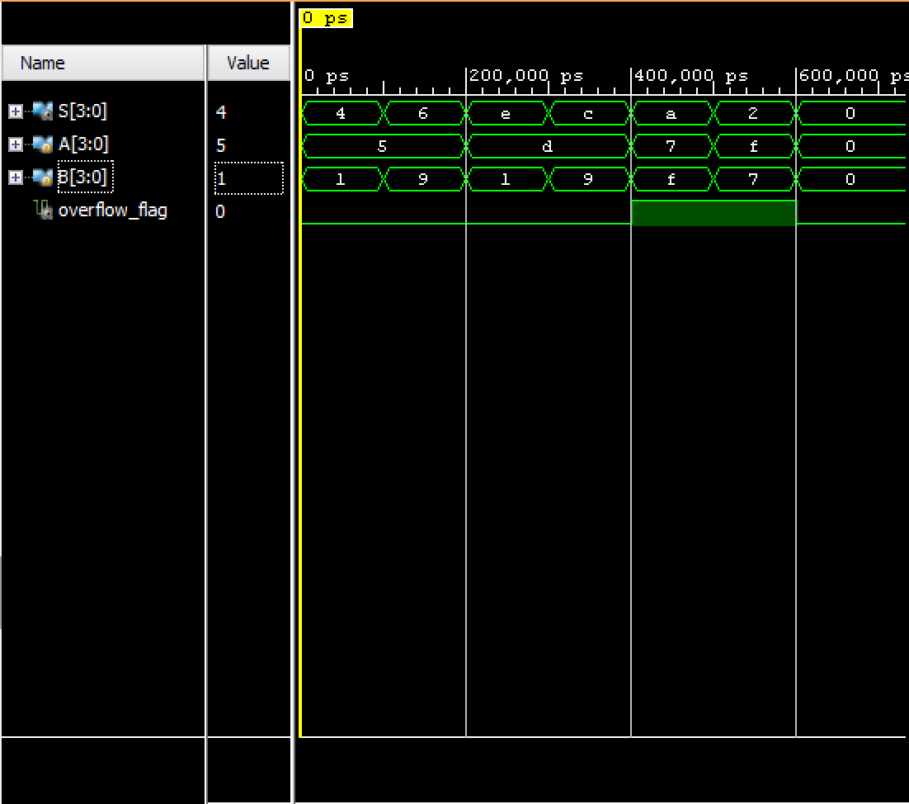

**Verilog Code**

|  |  |
| --- | --- |
| **module full_fourbit_subtractor(** input [3:0] A, input [3:0] B, output [3:0] S, output overflow_flag ); wire [3:0] i1; // Intermediate wires wire [3:0] i2; wire [3:0] i3; wire [3:0] i4; wire [3:0] i5; wire [3:0] i6; wire [3:0] i7; wire [3:0] i8; wire [3:0] i9; wire carry; wire neg_flag; wire zero_flag, zero_flag1; assign i7 = A & 4'b0111; // Masking out MSB to remove sign assign i8 = B & 4'b0111; twos_complement C1 (i7, i1, zero_flag); // Twos-complement for negative twos_complement C2 (i8, i2, zero_flag1); assign i3 = (A[3] == 0) ? i7 : i1; assign i4 = (B[3] == 1) ? i8 : i2; fourbit_full_adder A1 (i3, i4, 1'b0, i5, not_neg_flag); reverse_twos_complement C3 (i5, i6); assign neg_flag = (i5[3] == 0) ? 0 : 1; assign i9 = (neg_flag == 0) ? i5 : i6; assign S = (neg_flag == 0) ? (i9 & 4'b0111) : (i9 | 4'b1000); // Adding sign back in assign overflow_flag = (i3[3] != i4[3]) ? 0 : ((i3[3] == i5[3]) ? 0 : 1); **endmodule**  **module onebit_full_adder(** input A, input B, input CIN, output S, output COUT ); assign S = (A ^ B) ^ CIN; assign COUT = (A & B) | (CIN & (A ^ B)); **endmodule** | **module fourbit_full_adder(** input [3:0] A, input [3:0] B, input CIN, output [3:0] S, output COUT ); wire C1, C2, C3; onebit_full_adder A1 (A[0], B[0], CIN, S[0], C1); onebit_full_adder A2 (A[1], B[1], C1, S[1], C2); onebit_full_adder A3 (A[2], B[2], C2, S[2], C3); onebit_full_adder A4 (A[3], B[3], C3, S[3], COUT);**endmodule**  **module twos_complement(** input [3:0] A, output [3:0] B, output zero_flag ); fourbit_full_adder A1 ((~A), 4'b0001, 1'b0, B, zero_flag);**endmodule**  **module reverse_twos_complement(** input [3:0] IN, output [3:0] OUT ); wire dummy; wire [3:0] intermediate; fourbit_subtractor C1(IN, 1'b0001, intermediate, dummy); assign OUT = ~intermediate; **endmodule**  **module fourbit_subtractor(** input [3:0] A, input [3:0] B, output [3:0] S, output neg_flag ); wire [3:0] intermediate; wire not_neg_flag; wire zero_flag; twos_complement C1 (B, intermediate, zero_flag); fourbit_full_adder A1 (A, intermediate, 1'b0, S, not_neg_flag); assign neg_flag = (zero_flag == 0) ? (~(not_neg_flag)) : (not_neg_flag); **endmodule**  **module simulation(** ); wire [3:0] S; wire overflow_flag; reg [3:0] A; reg [3:0] B; full_fourbit_subtractor dut (A, B, S, overflow_flag); initial begin A = 4'b0101; B = 4'b0001; #100; A = 4'b0101; B = 4'b1001; #100; A = 4'b1101; B = 4'b0001; #100; A = 4'b1101; B = 4'b1001; #100; A = 4'b0111; B = 4'b1111; #100; A = 4'b1111; B = 4'b0111; #100; A = 4'b0000; B = 4'b0000; #100; end**endmodule** |